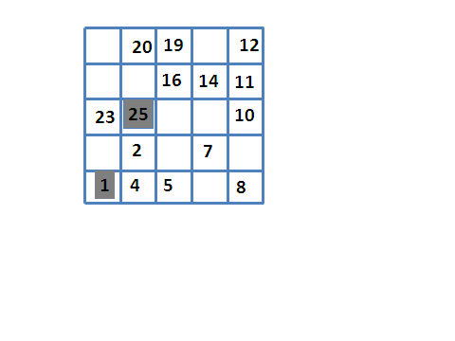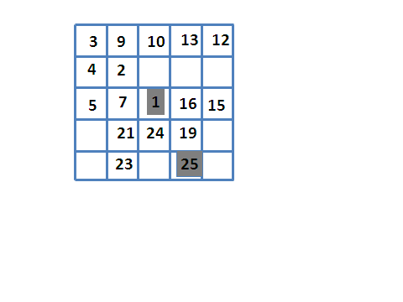

Allena…Menti -

6° incontro

10 dicembre 2019

Hidato

* Inserire nella griglia i numeri mancanti in modo da creare un percorso di caselle adiacenti tra loro (anche in diagonale) contenenti in sequenza tutti i numeri da 1 al numero finale( nella casella grigia)

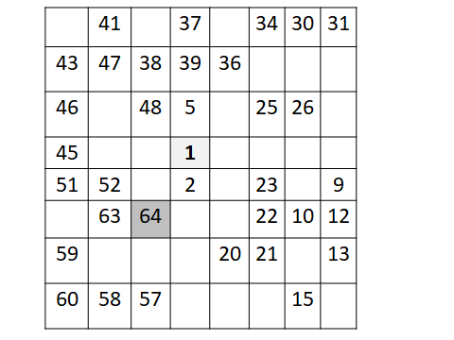

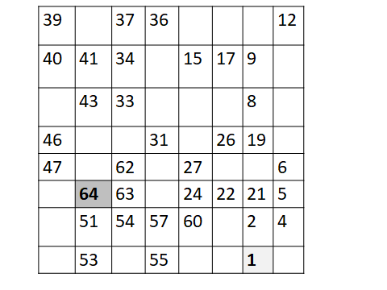

|  |  |  |  |  |  |  |  |  |  |  |  |
| --- | --- | --- | --- | --- | --- | --- | --- | --- | --- | --- | --- |
|  |  |  |  |  | **Hidato** | | | |  |  |  |
|  |  |  |  |  |  |  |  |  |  |  |  |
|  |  |  |  |  | **19** | **16** | **17** |  |  | **7** | **6** |
|  |  | **40** | **37** | **42** | **21** | **18** | **15** | **9** | **11** |  |  |
|  | **29** | **27** |  | **36** | **43** |  | **14** |  | **4** | **85** |  |
|  | **30** |  | **33** | **34** |  |  |  | **3** | **2** |  |  |
|  |  | **32** |  |  | **47** | **95** | **45** | **1** |  | **87** | **88** |
|  |  | **50** |  |  | **96** |  |  | **80** | **92** |  | **89** |
|  |  |  | **49** | **52** | **64** | **97** | **69** | **93** |  | **75** |  |
|  | **59** | **57** |  | **63** |  |  |  | **70** | **74** | **78** | **76** |
|  | **58** | **60** | **61** |  |  | **66** | **99** |  | **72** |  | **77** |
|  |  |  |  |  |  |  |  |  |  |  |  |
|  |  |  |  |  |  |  |  |  |  |  |  |

|  |  |  |  |  |  |  |  |  |  |  |  |  |  |  |  |  |  |  |  |  |  |  |  |  |  |  |  |  |  |  |  |  |  |  |  |  |  |  |  |  |  |  |  |  |  |  |  |  |  |  |  |  |  |  |  |  |  |  |  |  |  |  |  |  |  |  |  |  |  |  |  |  |  |  |  |  |  |  |  |  |  |  |  |  |  |  |  |  |  |  |  |  |  |  |  |  |  |  |  |  |  |  |  |  |  |  |  |  |  |  |  |  |  |  |  |  |  |  |  |  |  |  |  |  |  |  |  |  |  |  |  |  |  |  |  |  |  |  |  |  |  |  |  |  |  |  |  |  |  |  |  |  |  |  |  |  |
| --- | --- | --- | --- | --- | --- | --- | --- | --- | --- | --- | --- | --- | --- | --- | --- | --- | --- | --- | --- | --- | --- | --- | --- | --- | --- | --- | --- | --- | --- | --- | --- | --- | --- | --- | --- | --- | --- | --- | --- | --- | --- | --- | --- | --- | --- | --- | --- | --- | --- | --- | --- | --- | --- | --- | --- | --- | --- | --- | --- | --- | --- | --- | --- | --- | --- | --- | --- | --- | --- | --- | --- | --- | --- | --- | --- | --- | --- | --- | --- | --- | --- | --- | --- | --- | --- | --- | --- | --- | --- | --- | --- | --- | --- | --- | --- | --- | --- | --- | --- | --- | --- | --- | --- | --- | --- | --- | --- | --- | --- | --- | --- | --- | --- | --- | --- | --- | --- | --- | --- | --- | --- | --- | --- | --- | --- | --- | --- | --- | --- | --- | --- | --- | --- | --- | --- | --- | --- | --- | --- | --- | --- | --- | --- | --- | --- | --- | --- | --- | --- | --- | --- | --- | --- | --- | --- | --- |
| |  |  |  |  |  |  |  |  |  |  |  |  |  | | --- | --- | --- | --- | --- | --- | --- | --- | --- | --- | --- | --- | --- | |  |  |  |  |  |  | **Hidato** | | | |  |  |  | |  |  |  |  |  |  |  |  |  |  |  |  |  | |  |  | **48** | **47** |  | **30** | **28** |  |  |  | **23** | **12** | **11** | |  |  |  |  | **46** |  |  | **27** |  | **24** |  |  | **9** | |  |  | **43** | **45** | **50** | **34** |  |  | **19** |  |  |  | **8** | |  |  | **41** |  | **39** |  | **35** |  |  |  | **6** | **7** | **87** | |  |  |  |  | **52** | **38** |  | **36** | **4** |  | **89** |  |  | |  |  |  | **65** |  |  | **37** |  |  | **90** | **92** | **85** |  | |  |  |  |  |  | **60** | **58** |  | **2** | **82** |  |  |  | |  |  |  |  |  | **67** | **59** |  | **1** | **81** | **83** |  | **98** | |  |  | **72** | **73** | **74** |  |  | **77** |  | **79** |  | **97** | **99** | |  |  |  |  |  |  |  |  |  |  |  |  |  | |
|  |