Allena…Menti 2020 - 3 marzo 2020

Camping

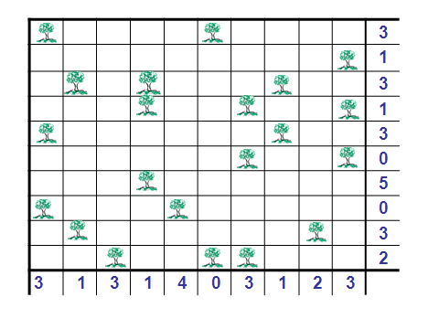



|  |  |  |  |  |  |  |  |  |  |  |
| --- | --- | --- | --- | --- | --- | --- | --- | --- | --- | --- |
|  |  |  |  |  |  |  |  |  |  | 1 |
|  |  |  |  |  |  |  |  |  |  | 3 |
|  |  |  |  |  |  |  |  |  |  | 0 |
|  |  |  |  |  |  |  |  |  |  | 3 |
|  |  |  |  |  |  |  |  |  |  | 1 |
|  |  |  |  |  |  |  |  |  |  | 3 |
|  |  |  |  |  |  |  |  |  |  | 1 |
|  |  |  |  |  |  |  |  |  |  | 3 |
|  |  |  |  |  |  |  |  |  |  | 2 |
|  |  |  |  |  |  |  |  |  |  | 1 |
| 2 | 2 | 1 | 2 | 2 | 1 | 4 | 0 | 4 | 0 |  |

|  |  |  |  |  |  |  |  |  |  |  |  |
| --- | --- | --- | --- | --- | --- | --- | --- | --- | --- | --- | --- |
|  |  |  |  |  |  |  |  |  |  |  |  |